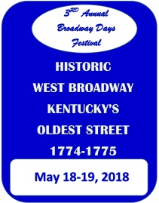
Broadway Days 2018
Sponsor Letter - Application
Dear Friend:
We the citizens of the African-American Community have formed a new festival for our community, the Broadway Days Festival. This festival is to celebrate West Broadway Street (which was formerly Water Street), the oldest street in Kentucky. West Broadway was established in 1774-1775 and created travel and communication throughout the town and was the place to see and be seen with the abundance of commerce and social activities that occurred there on a daily basis. This new festival is no parts of the former Roots and Heritage Festival, we are -a new board with a new name.
On May 18-19, 2018 we want to celebrate this town Gem with Live Music, Games, Vendors, Food, Fashion, Speakers, Comedy, Gospel and much more.
Thanks for your level of support. You may sponsor a corner street (Fort & Broadway); Street (program); West Broadway (which will place your business on the shirt) or a corporate sponsor (Signage and Media).
For more information you may contact the President, Sid Dunn at 609-254-6984. You may make your check payable to the Broadway Days Festival, 726 Cane Run Street, Harrodsburg, KY 40330.
Thanking you in advance for your cooperation in this matter.
Please check below your type of sponsorship:
$25 Corner
$50 Street |  | Program
$100 Broadway |  | Shirt (name will be placed on shirts as a sponsor)
$500 Corporate |  | Signage and Media
Other |  | Donation (Amount__________

Contact Name
Business Name
Street Address
City, State, Zip
Phone Number
E-Mail

Broadway Days Festival ● 726 Cane Run Street ●Harrodsburg, KY 40330 ● Phone 609-254-6984

FOR OFFICE USE ONLY:

Date Received _______________ Initial ______________
Cash _______________
Money Order _______________ Money Order # ______________
Check ______________ Check # ______________

